Practical - 3

Practical Title: Responsive UI Design using CSS Grid, Flexbox, and Bootstrap/Tailwind

Problem Definition: Design responsive layouts for Home, About, Registration, Dashboard, and Events pages using CSS Grid and Flexbox. Optional to use CSS framework such as Bootstrap or Tailwind. Ensure mobile-first responsiveness.

Theory:
- How does the layout adapt for mobile, tablet, and desktop screens?
The layout is made responsive using flexible sizes and media queries. This helps the content adjust properly according to different screen sizes without disturbing the overall design.
- Which layout technique is used and why?
Flexbox is mainly used because it makes it easier to arrange the elements in rows or columns and adjust them according to the screen size.
- Is typography, spacing, colours, and contrast readable?
Yes, the font size, spacing, and colours are kept simple and clear. Proper contrast between the background and text makes the content easy to read.
- Is the framework used consistently without unnecessary inline CSS?
Yes, the styling is kept mostly in the CSS files instead of using unnecessary inline CSS. This keeps the code organized and makes future changes easier.

- Implementation/ Output/Result
https://github.com/margiruparel2907-collab/webdev/tree/master/CSS

- Evidence of Work (Screenshots)
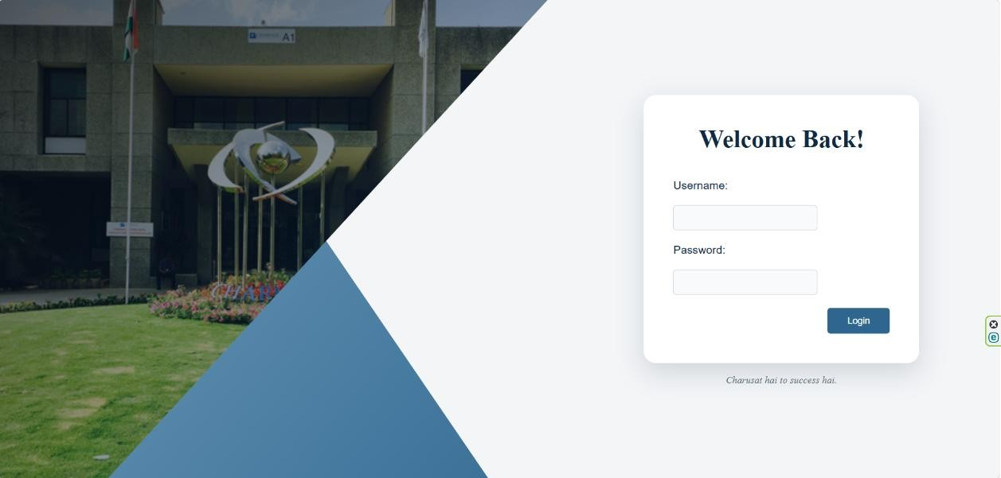
Login page
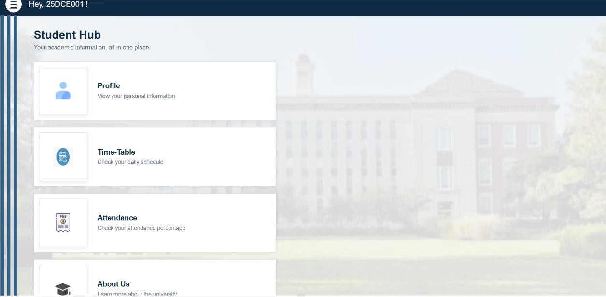
Dashboard page
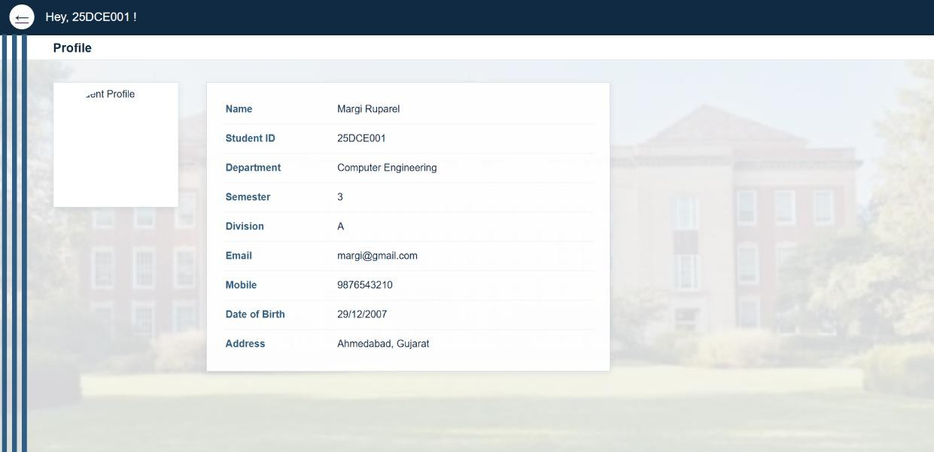
Profile page
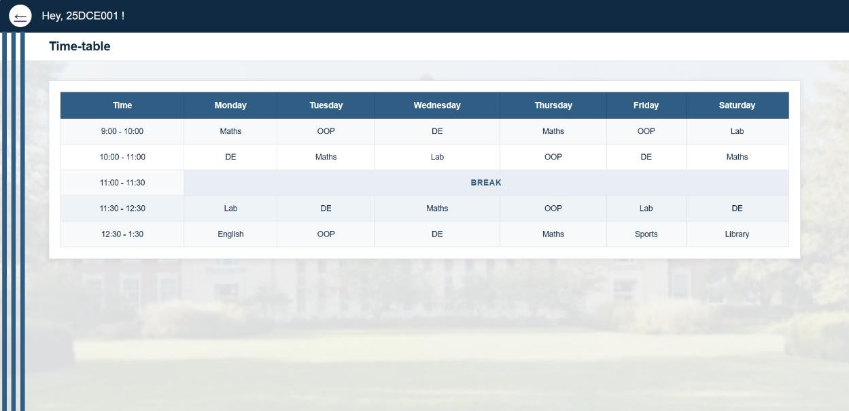
Time-Table page
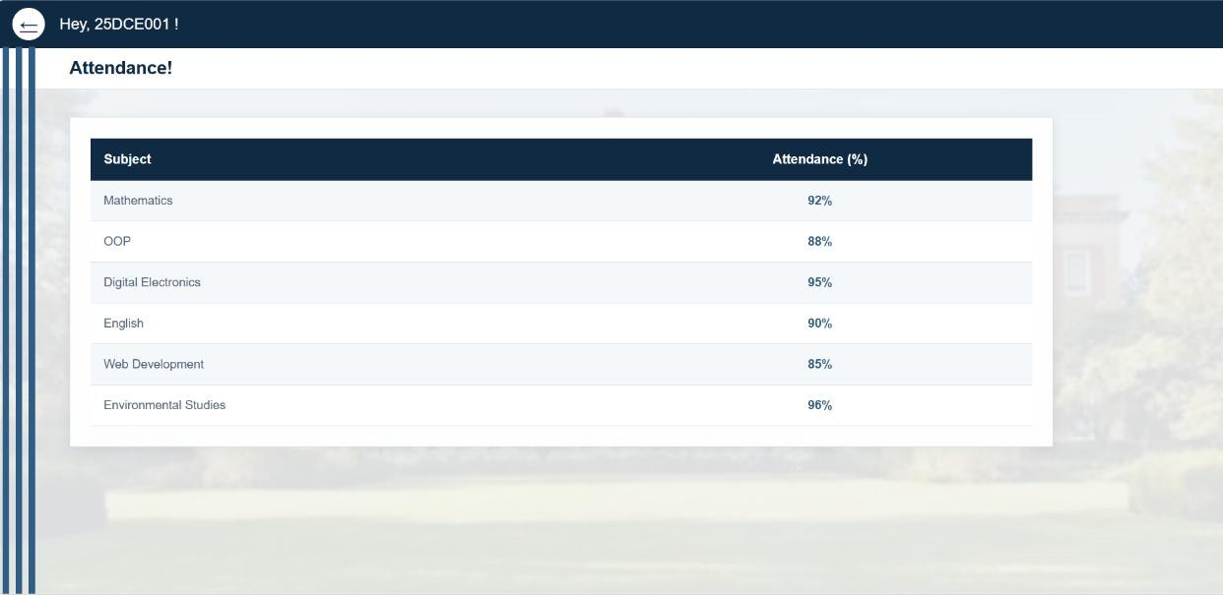
Attendance page
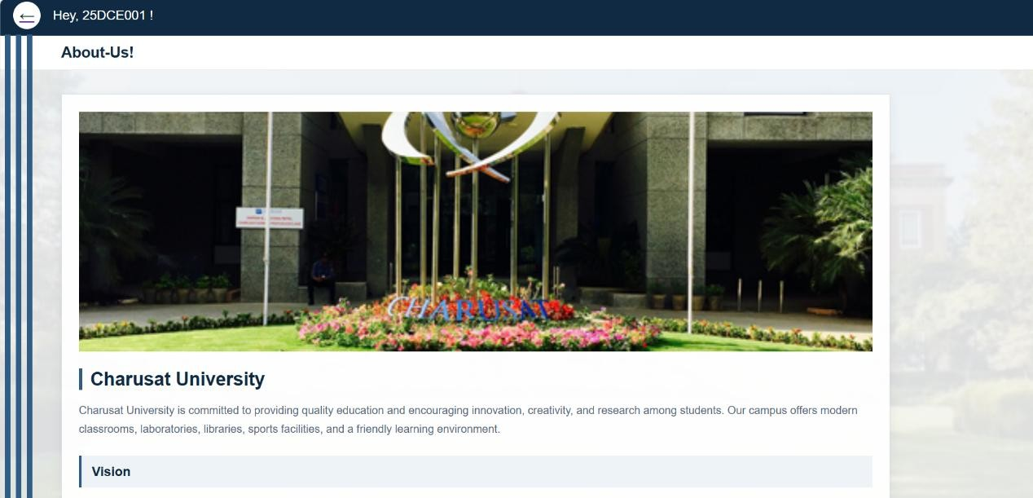
About-us page

Menu page
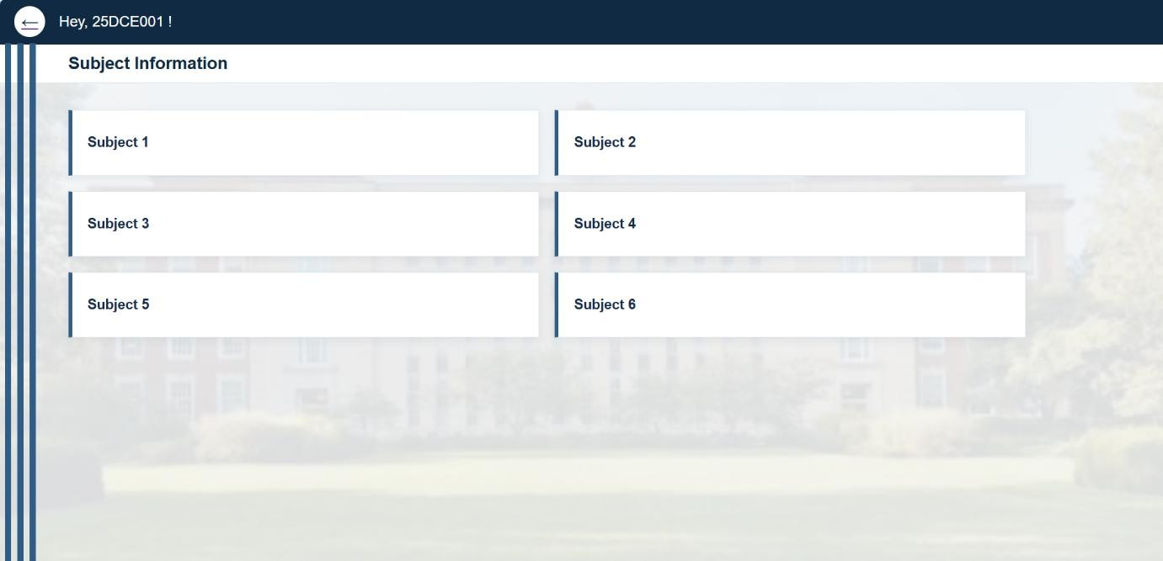
Subject information page
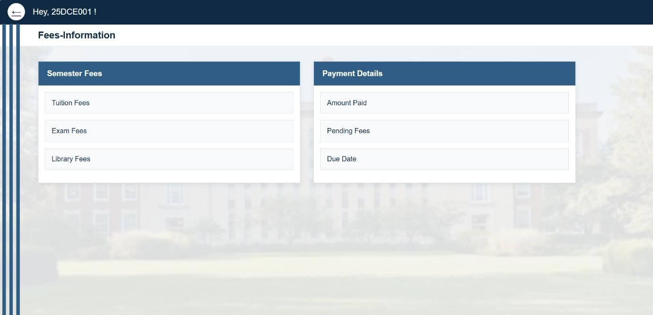
Fees information page
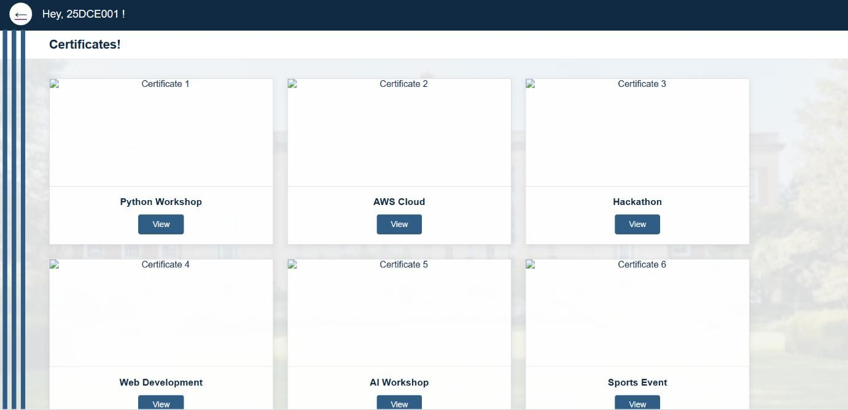
Certificates page
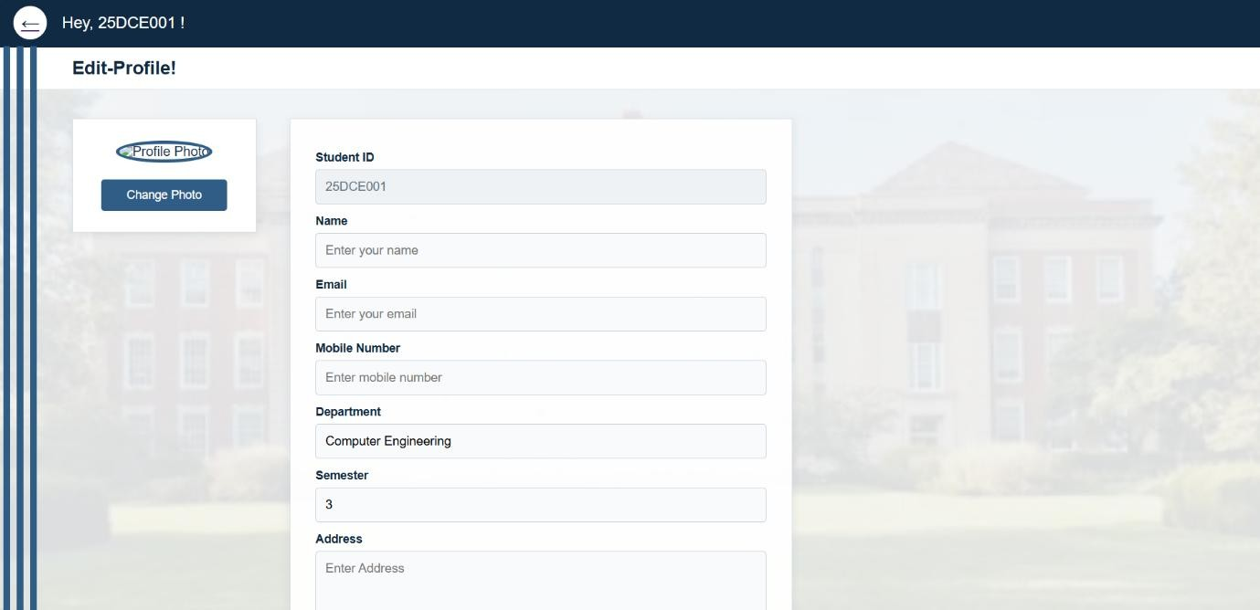
Edit profile
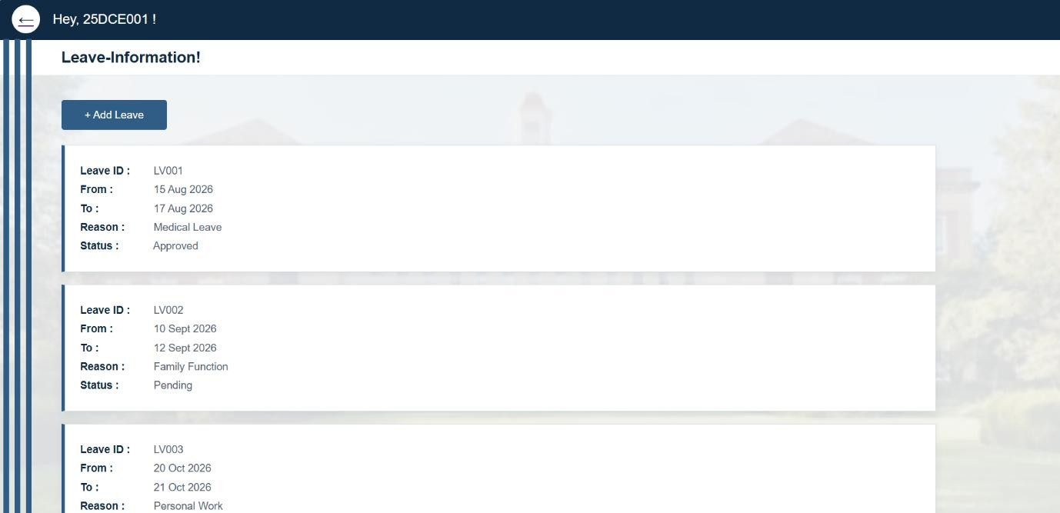
Leave information

- GitHub Repository Link:
https://github.com/margiruparel2907-collab/webdev

- Challenges Faced:
While designing the pages, the main difficulty was making the layout look proper on different screen sizes. Some elements were aligned correctly on desktop but needed adjustment for smaller screens. I also faced some issues with spacing, image sizes, and keeping the login and dashboard sections balanced. Choosing suitable colors and maintaining the same design style on all pages also took some time. Using Flexbox and Grid properly was a little confusing at first, but testing the pages in responsive mode helped me understand it better.

- Learning Outcomes:
After making the required changes, the pages became more organized and responsive. The login page and Student Hub dashboard were designed with a consistent color scheme, proper spacing, readable text, and clear sections. I also understood how media queries, Flexbox, and Grid can be used to adjust a webpage for different devices. Overall, I learned how to create a cleaner and more user-friendly interface and how to check the design on different screen sizes.

Faculty Remarks: (Keep this blank for faculty)

